Week 1 Hands-on Activity

Task 1: Screenshot of Directory Structure and File Permission
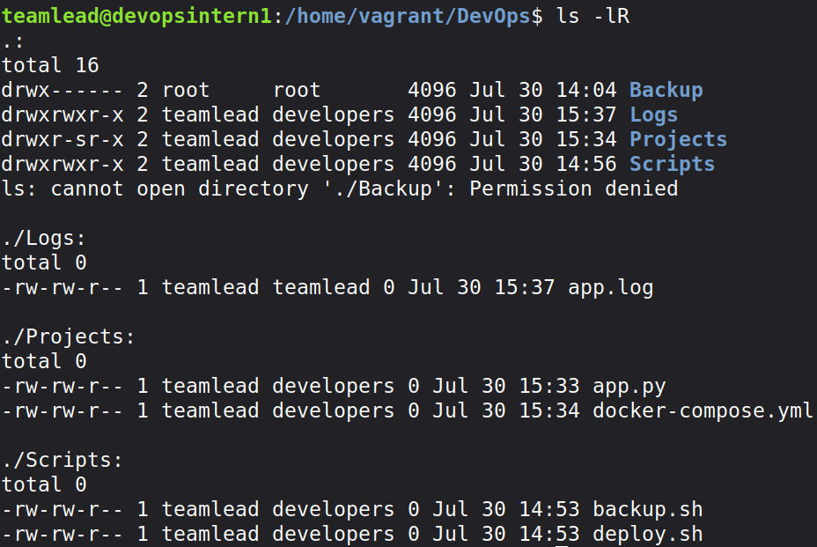

Task 2: Screenshot of Users & Groups

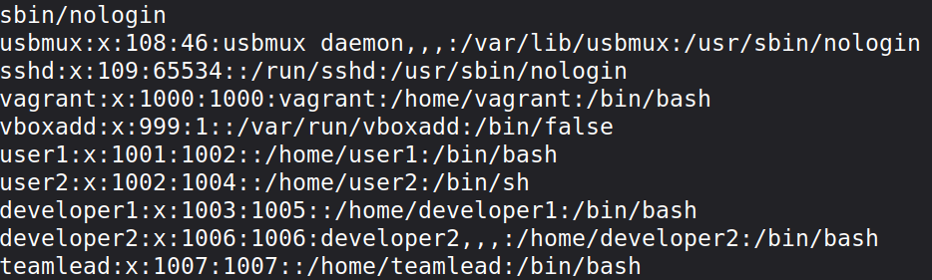
f.g: Users List

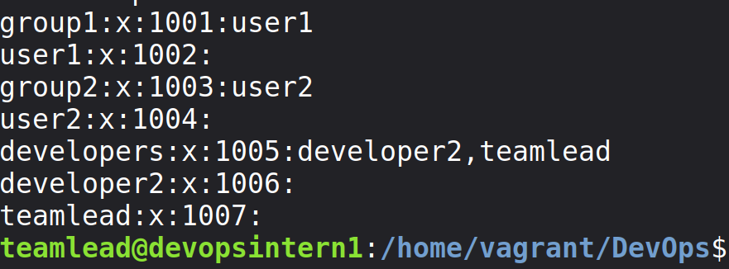
f.g : Group list

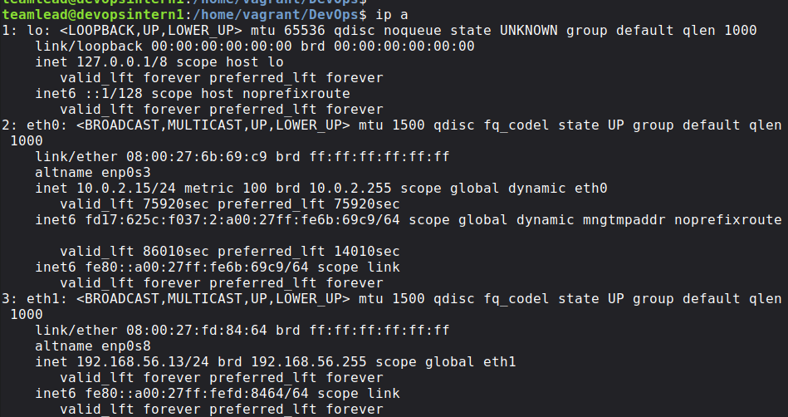
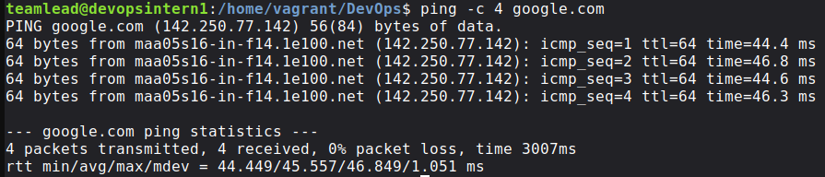
Task 3: Screenshot of Network Connectivity ( ip a , ping)

Task 4 : Short implementation summary (4–5 lines)
Step 1 : Make a directory using mkdir – p and touch command
Step 2 : Change permission and ownership using chmod command
Step 3 : Change perm

